Ungulate effects on soil characteristics.
Soil texture Soil description Ej Quintos
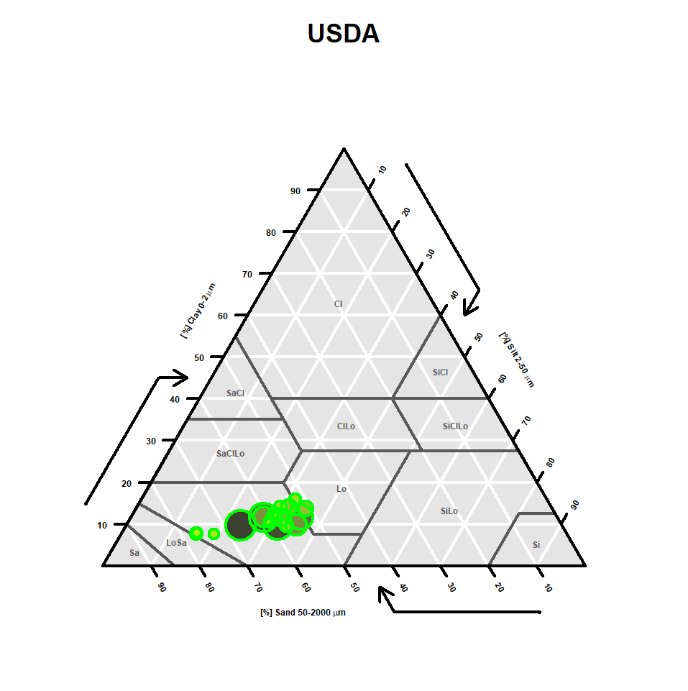
IF YOU CAN DO A BETTER FIGURE WITH DIFFERENT COLORS FOR THE DIFERENT TREATMENTS AN DIFERENT SHAPE FOR MUELA AND QUINTOS IT WILL BE GREAT
I GIVE YOU AN EXAMPLE I FOUND IN INTERNETVhttps://www.linkedin.com/pulse/visualizing-soil-texture-data-using-r-dr-saurav-das-y6qtc

Physic response of soil to ungulate presence
Apparent density
MUELA DE CORTES
> anova(lm((MuelaAD$`GlobalAD(g/cm3)`~MuelaAD$Treatment*MuelaAD$data)))
Analysis of Variance Table

Response: MuelaAD$`GlobalAD(g/cm3)`
Df Sum Sq Mean Sq F value Pr(>F)
MuelaAD$Treatment 3 0.18996 0.063320 2.5904 0.05785 .
MuelaAD$data 1 0.07200 0.071995 2.9453 0.08965 .
MuelaAD$Treatment:MuelaAD$data 3 0.23032 0.076774 3.1408 0.02927 *
Residuals 88 2.15110 0.024444
---
Signif. codes: 0 ‘***’ 0.001 ‘**’ 0.01 ‘*’ 0.05 ‘.’ 0.1 ‘ ’ 1

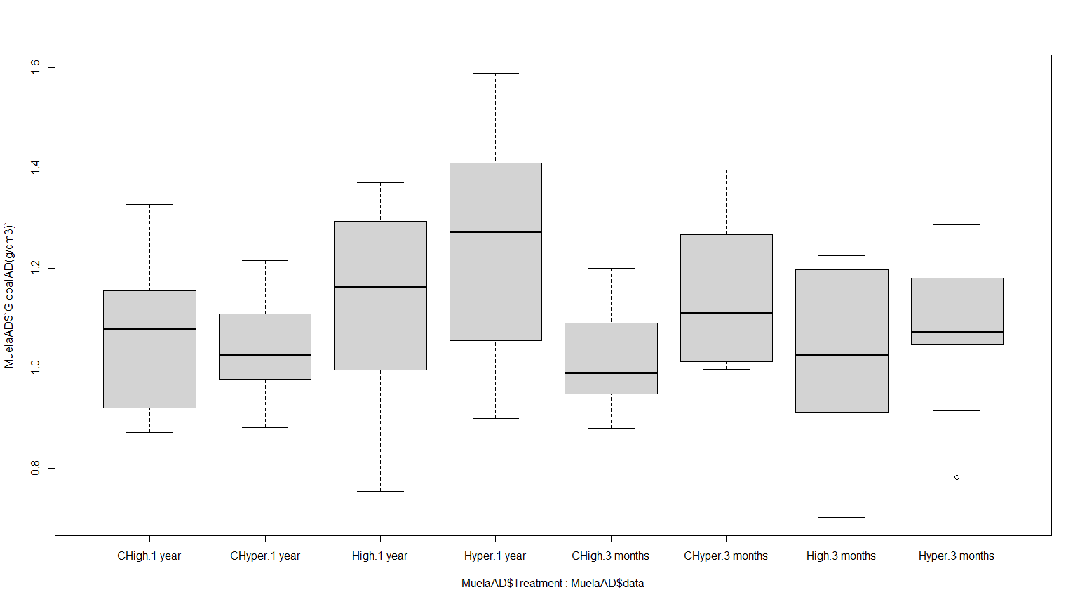
emmeans_result <- emmeans(model, ~ Treatment | data)
tukey_result <- contrast(emmeans_result, method = "tukey")
Treatment emmean SE df lower.CL upper.CL .group
CHyper 1.05 0.0451 88 0.956 1.14 a
CHigh 1.06 0.0451 88 0.974 1.15 a
High 1.14 0.0451 88 1.047 1.23 ab
Hyper 1.25 0.0451 88 1.158 1.34 b

data = 3 months:
Treatment emmean SE df lower.CL upper.CL .group
CHigh 1.02 0.0451 88 0.927 1.11 a
High 1.03 0.0451 88 0.942 1.12 a
Hyper 1.08 0.0451 88 0.992 1.17 a
CHyper 1.14 0.0451 88 1.055 1.23 a

Quintos de Muela
No significant effect of treatment or time but yes habitat
Response: Soil_densityINCREMENTO$`BD(g/ml)`
Df Sum Sq Mean Sq F value Pr(>F)
Soil_densityINCREMENTO$Cercado 2 0.1647 0.082357 1.9199 0.15193
Soil_densityINCREMENTO$time 1 0.0125 0.012515 0.2918 0.59028
Soil_densityINCREMENTO$Hábitat 1 0.1741 0.174095 4.0586 0.04661 *
Residuals 101 4.3324 0.042895
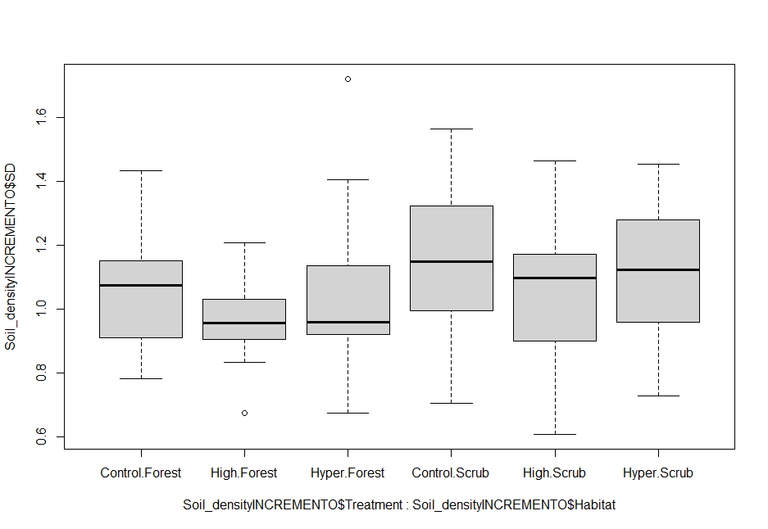

Cercado = Control:
Hábitat emmean SE df lower.CL upper.CL .group
Forest 1.061 0.0401 101 0.982 1.14 a
Scrub 1.142 0.0407 101 1.062 1.22 b

Cercado = High:
Hábitat emmean SE df lower.CL upper.CL .group
Forest 0.972 0.0400 101 0.893 1.05 a
Scrub 1.053 0.0400 101 0.974 1.13 b

Cercado = Hyper:
Hábitat emmean SE df lower.CL upper.CL .group
Forest 1.049 0.0407 101 0.969 1.13 a
Scrub 1.130 0.0401 101 1.051 1.21 b

Clear results on Muela where de AD increase in treatments with ungulates only after 1 year, we need to generate good figures with statistical results in them.

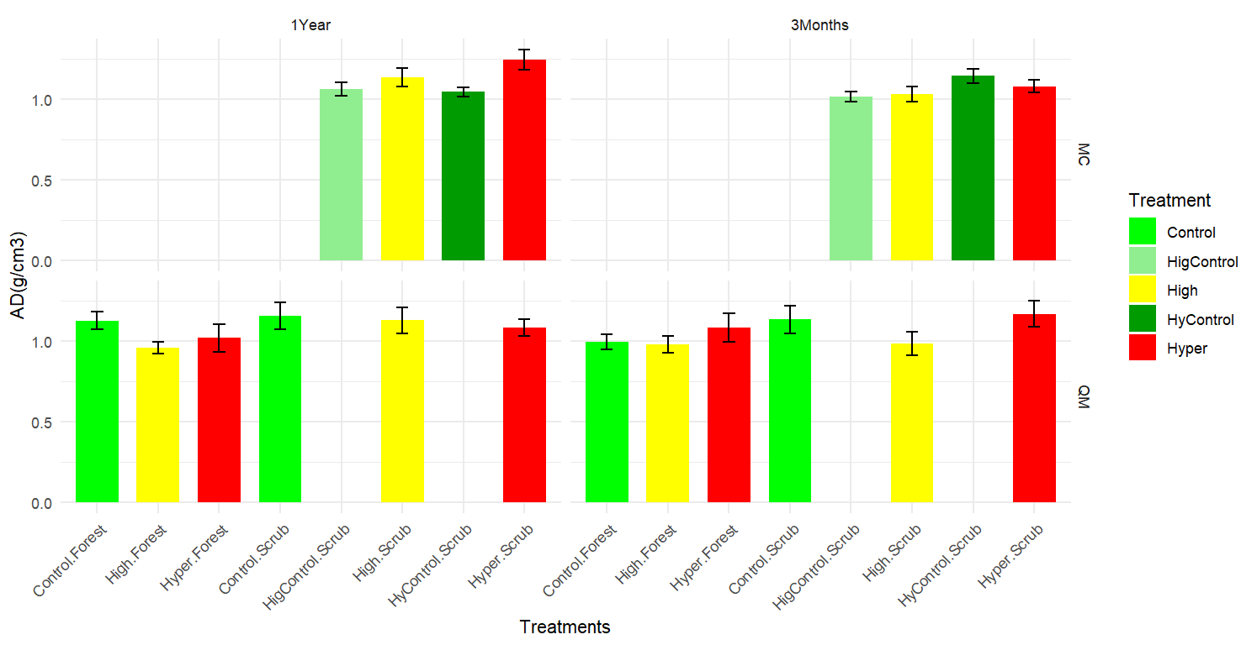

Ungulate effect on organic matter accumulation (the soil sampling was done one year after the ungulates were in the excisions and 3 samples were taken in place where the use of ungulates where clear since there was faecal pellets accumulation)
Analysis of Variance Table

Response: Organic Carbon
Df Sum Sq Mean Sq F value Pr(>F)
treatment 2 25.458 12.729 6.6017 0.01165 *
habitat 1 94.761 94.761 49.1470 1.413e-05 ***
Treatment habitat 2 16.165 8.083 4.1920 0.04163 *
Residuals 12 23.137 1.928
---
Analysis of Variance Table

Response: pH
Df Sum Sq Mean Sq F value Pr(>F)
treatment 2 0.23444 0.11722 1.0243 0.38842
habitat 1 0.64222 0.64222 5.6117 0.03547 *
treatment:habitat 2 0.06778 0.03389 0.2961 0.74898
Residuals 12 1.373

Response: log(Conductivity)
Df Sum Sq Mean Sq F value Pr(>F)
treatment 2 1.9640 0.9820 4.5370 0.0340883 *
habitat 1 5.7244 5.7244 26.4477 0.0002439 ***
treatment:habitat 2 0.8698 0.4349 2.0094 0.1767259
Residuals 12 2.5973 0.2164

We need to improve the table putting the SE close to the mean as que example and including letter to indicate statistically differences.

Area | Habitat | Treatment | Mean OC (%) | SE OC | Mean Cond (dS/m) | SE | mean pH | SE
QM | Forest | Control | 4.50 ±0.51 |  | 0.09 | 0.02 | 6.17 | 0.20
QM | Forest | High | 8.50 | 0.87 | 0.33 | 0.07 | 6.00 | 0.21
QM | Forest | Hyper | 9.25 | 1.28 | 0.24 | 0.13 | 5.83 | 0.20
QM | Scrub | Control | 2.39 | 0.92 | 0.05 | 0.01 | 5.63 | 0.19
QM | Scrub | High | 3.56 | 0.47 | 0.06 | 0.01 | 5.77 | 0.26
QM | Scrub | Hyper | 2.54 | 0.37 | 0.05 | 0.01 | 5.47 | 0.03
MC | Scrub | High | 4.20 | 0.88 | 0.12 | 0.03 | 7.00 | 0.06
MC | Scrub | Hyper | 4.16 | 0.25 | 0.13 | 0.01 | 7.20 | 0.15
MC | Scrub | Control | 2.45 | 0.31 | 0.10 | 0.01 | 7.60 | 0.06
MC | Scrub | Control | 2.89 | 0.05 | 0.13 | 0.01 | 7.60 | 0.10

SOIL nutrients
We have 9 replication per exclusion 1 year after treatment. I made a PCA with nutrient characteristics.
Area (QM quintos de Mora / MC mula de cortes (squares) ) Treatments (Control greens. high density of ungulates yellows. hyperdensity of ungulates reds) and habitat (forest solid symbols or scrubs)

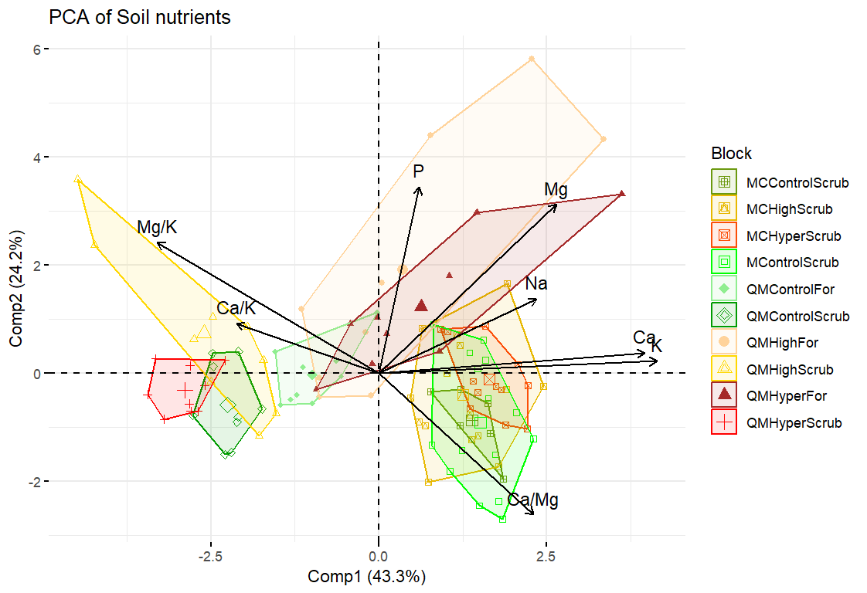
Muela de Cortes all treatments are in the right bottom presenting more Ca/Mg
Quintos de Mora Scrubland of all treatments are in the left part presenting higher Mg/K and C/K ratios
Quintos de Mora Forest treatments are more different to each other. soils with ungulated presence were mor heterogeneous with some sampling points presenting high P and Mg concentrations

